Scrum - Rituals Workbook

Iterative Time-box Activities

| Analyze |
| --- |
| Design |
| Construct |
| Integrate |
| Test |

Quality of an Iteration

| The degree to which an iteration meets set goals, standards, and team commitments. |
| --- |

Quality of Outcome Determination

| The process of assessing if outcomes align with customer expectations, goals, and deliverables |
| --- |

| Sprint definition - The heart of scrum, which is 1 month or less. It’s a time box for creating an increment. Team determines length based upon their belief of what would work best to enhance team productivity. |
| --- |

| Determination of length of sprint - Typically a 2 - 4 week span |
| --- |

Sprint Rituals

| Sprint Planning Meeting | Expectations as to the amount of work that can be performed or the length of time until something is finished. |
| --- | --- |
| Estimation | The act of determining (guessing) the expected size of something. |

3 types of estimation When this occurs Unit of measure

| Portfolio | Porfolio planning | T-shirt sizes |
| --- | --- | --- |
| Product Backlog | Product backlog grooming | Story points / ideal days |
| Sprint Backlog Tasks | Sprint Planning | Ideal hours / effort-hours |

Scrum Roles Involved in Estimation

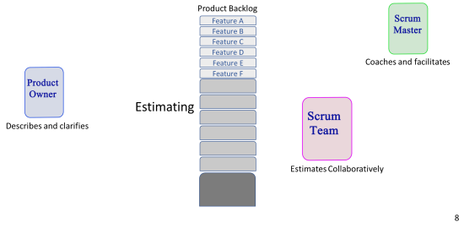Planning Poker Triangulation

| Ideal day / Ideal hour:  Occurs during Sprint planning |
| --- |
| Problems with Ideal estimation  Uninterrupted focus and interruptions |

Daily Standup

| Purpose  To adopt the plan for the next day to ensure that the team move forward toward a successful increment  Every day, the Development Team should understand how it intends to work together as a self-organizing team to accomplish the Sprint Goal and create the anticipated Increment by the end of the Sprint  To |
| --- |
| 3 Questions   * What did you do since the last meeting? * What are you planning to do before the next meeting? * Do you experience any obstacles? |
| Rules  The Scrum Master asks the questions. Same place and time every day. For synchronization, not problem-solving. A short meeting may be held after the Scrum meeting to resolve issues (only attended by relevant team members). Time box: 15 minutes daily |

Pair Programming

| In Pair programming, two developers work together on the code. Both sit at the same computer and create one requirement. They pass the keyboard and mouse back and forth to collaborate. This way they catch errors easily. |
| --- |

Sprint Review Meeting

| Purpose  To inspect the Increment and adapt the Product Backlog if needed. During the Sprint Review, the Scrum Team and stakeholders collaborate about what was done in the Sprint. Based on that and any changes to the Product Backlog during the Sprint, attendees collaborate on the next things that could be done to optimize value. |
| --- |
| Participants  Scrum master  Product owner  Scrum team  External stakeholders  Customer  Users |
| Timing  4 hrs max |
| Location  organisation |
| Expected Outcomes  Presentation of the Increment is intended to elicit feedback and foster collaboration. |

Sprint Retrospective Meeting

| The Sprint Retrospective is an opportunity for the Scrum Team to inspect itself and create a plan for improvements to be enacted during the next Sprint. |
| --- |
| Purpose  Improvements of process for future  What could be improved  What worked well  What will the team commit to doing in the next sprint |
| Three hours max |
| Participants:  Product owner  Scrum master  Scrum team |
|  |

Ritual Timing

| Sprint Duration | one month |
| --- | --- |
| Daily Stand-up | 15 mins |
| Spring Planning | 8 hrs |
| Spring Review | 4 hrs |
| Sprint Retrospective | 3 hrs |

